**Training PowerPoints Available for CACFP in Spanish**

**(Presentaciones de entrenamiento** **disponibles** **para el CACFP en** **español)**

**Website (El Sitio Web):** [**https://www.fns.usda.gov/tn/meal-pattern-training-slides-cacfp**](https://www.fns.usda.gov/tn/meal-pattern-training-slides-cacfp)

**Grains (Granos)**

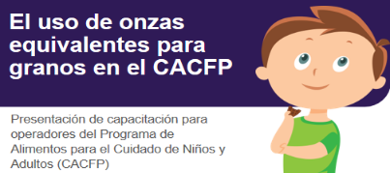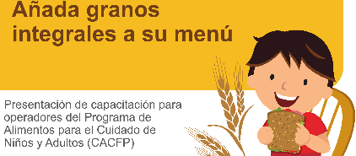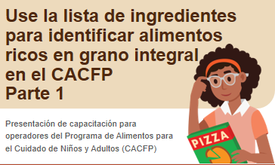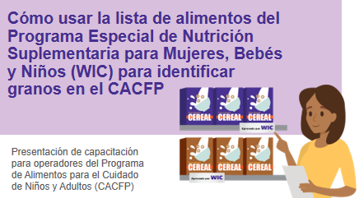

Crediting Single-Serving Packages of Grains

Adding Whole Grains to Your Menu

Using Ounce Equivalents

Using the WIC Food Lists to Identify Grains

Identifying Whole Grain-Rich Foods Part 1

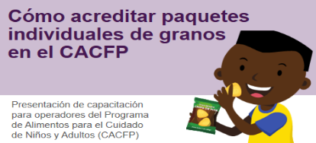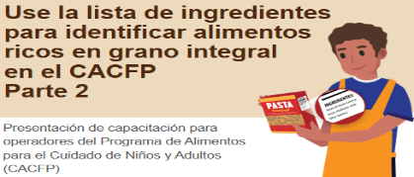

Identifying Whole Grain-Rich Foods Part 2

Crediting Store-Bought Combination Baby Foods

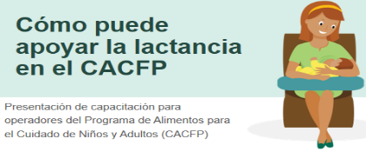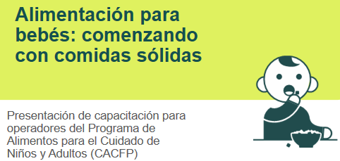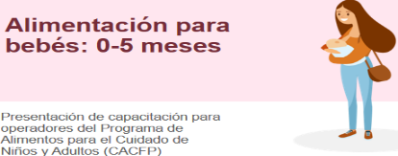

**Infants (Bebés)**

How to Support Breastfeeding

Feeding Infants: Starting with Solids

Feeding Infants: 0-5 months

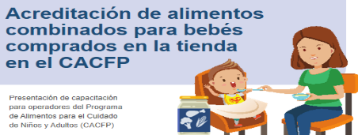

Crediting Store-Bought Combination Baby Foods

**Training PowerPoints Available for CACFP in Spanish**

**(Presentaciones de entrenamiento** **disponibles** **para el CACFP en** **español)**

**Website (El Sitio Web):** [**https://www.fns.usda.gov/tn/meal-pattern-training-slides-cacfp**](https://www.fns.usda.gov/tn/meal-pattern-training-slides-cacfp)

**Meat/ Meat Alternates (Carne/Sustitutos de Carne)**

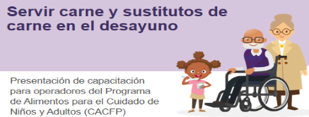

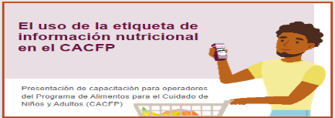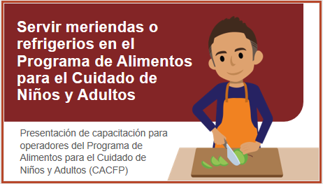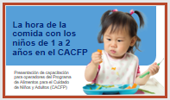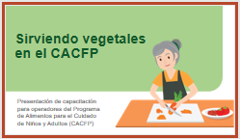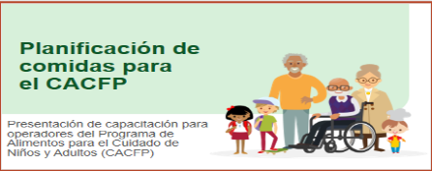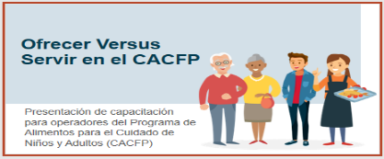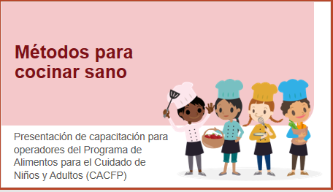

**Menu Planning (Planificación de comidas)**

Serving Meat/ Meat Alternates at Breakfast

Methods of Healthy Cooking

Serving Vegetables in CACFP

Serving Snacks in CACFP

Mealtimes with Toddlers in CACFP

Offer Versus Serve in CACFP

Meal Planning for CACFP

Using the Nutrition Facts Label in CACFP

**Training PowerPoints Available for CACFP in Spanish**

**(Presentaciones de entrenamiento** **disponibles** **para el CACFP en** **español)**

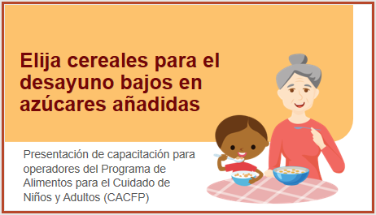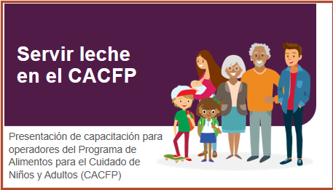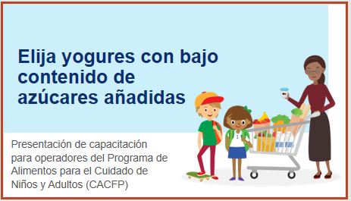**Website (El Sitio Web):** [**https://www.fns.usda.gov/tn/meal-pattern-training-slides-cacfp**](https://www.fns.usda.gov/tn/meal-pattern-training-slides-cacfp)

**Limits on Added Sugar (Bajos en azúcares añadidas)**

Choose Breakfast Cereals That Are Lower in Added Sugars

Serving Milk in CACFP

**Milk (Leche)**

Choose Yogurts That Are Lower in Added Sugars